Welcome to Beaver
Scouts
“Adventure all the way”
#SkillsforLife

Claygate Scout Centre
Oaken Lane
Claygate
Esher
Surrey
KT10 0RQ
Web site www.claygatescouts.org Tel: 01372 461770
Contents
1 Introduction from your Group Scout Leader 3
2 About the Beaver Scout Section 4
2.1 Aims of the Beaver Programme 4
2.2 The Uniform 5
2.3 Badges 5
2.4 The Beaver Scout Promise 6
2.5 The Beaver Scout Motto 6
2.6 The Investiture 6
2.7 Moving Up to Cubs 6
2.8 Points of Interest 6
3 About Group and District Activities 6
3.1 Beaver District Party 7
3.2 Cross Country Run 7
3.3 Group Activity Weekend 7
3.4 Beaver Fun Day 7
3.5 Scouts Own & Going-up Ceremony 7
3.6 Group Beer Festival 7
3.7 Group AGM & Annual Awards 7
3.8 Claygate Flower Show 8
3.9 St Georges Day 8
3.10 Group Fireworks 8
3.11 Remembrance Day Parade 8
3.12 Carols around the Camp Fire 8
4 Subscriptions 8
4.1 Subscriptions – by Gift Aid 8
5 Group Behaviour Policy and Code 9

Introduction from your Group Scout Leader
Your child is about to join 1st Claygate, one of the oldest Scout Groups in the world, and one of the largest and most successful in Surrey. 1st Claygate Scout Group has been providing Scouting in the village and surrounding area since 1909.
Those associated with the Group are proud of the fact that Scouting in Claygate is as relevant to our youngsters today as it was at the beginning of the last century. We are over a century old but are fortunate to have a relatively modern headquarters in Oaken Lane!
In this booklet we tell you about the Beaver Scout Section which your child is joining. We mention the other sections but you will receive more information as you move on up through the Group. There is an accompanying booklet which describes the structure of the Group and how it is run. Both are available in electronic versions on the 1st Claygate website www.claygatescouts.org under Group > Information > Welcome and Information Packs - here. I would encourage you to familiarise yourself with our policies especially those around Acceptable Behaviour and Photography & Social Media.
What has made Scouting the world’s largest voluntary movement for young people?
The answer lies in Scouting’s appeal to a young person’s desires for fun and adventure and its provision through attractive and active programmes. It provides opportunities for developing in young people the qualities that make good citizens: honour, self-discipline, dependability, respect for others and self-reliance.
Scouting aims to prepare young people to take a constructive place in society and does so, not by preaching at them, but by making the whole thing into a game in which it is fun to take part. That, more than anything else, is the secret of its appeal. However, in any game there have to be rules. The rules of the Game of Scouting are embodied in the Promise and Law.
Young people learn by doing, and Scouting offers activities to capture their imagination and enable each individual to find something in which to participate, develop skills and gain confidence. As far as possible, these activities take place outdoors as in camping, hiking, caving, sailing, mountaineering and many others, alongside a training programme which is structured from Beaver Scouts to Explorer Scouts.
Scouting at 1st Claygate is for boys and girls from 6 to 14 years. It teaches what is not learnt at home or at school and it assists their character development. However, they rely on adult volunteers to make it all possible, either as leaders to run their meetings, camps and so on, or as supporters to provide the material requirements and assist the leaders with the running of activities.
We hope your child will enjoy being a Beaver Scout and will continue through the family of sections.
When your child joins the Group you also become members of the Group Council, which usually meets once a year at the Group AGM. To ensure the Group continues to survive and flourish we expect you to support your child by either helping with a section, with the general running of the Group or with at least two fund-raising events a year. See here on our website for more information about membership requirements or via Group > Membership Requirements.
On starting you will receive an email with a personalised link for you to enter your child’s details on-line. Please ensure you complete this before your child attends as we cannot take charge of children if we don’t have contact details and be sure to let us know if your child has any special needs or dietary requirements when you complete this.
I believe 1st Claygate is a great organisation to be involved with and want everyone to feel welcome and engaged in Scouting. I am extremely proud to be Group Scout Leader and if you have any queries please do not hesitate to contact me.
Hugh Gostling, Group Scout Leader January 2024

About the Beaver Scout Section
There are 3 sections in the Group which your child may progress through until he/she is 14 years old: Beaver Scouts, Cub Scouts and Scouts (usually known as Beavers, Cubs and Scouts). After this he/she may choose to join the District Explorer Scout Unit which is based at 1st Claygate Scout Centre.
Your child will belong to one of the colonies in the Beaver Scout Section of 1st Claygate Scout Group. There are currently 4 colonies in the section: Maple, Oak, Sycamore and Willow, each meeting on different evenings. Each colony is led by a Beaver Scout Leader (BSL) assisted by one or more Assistant Beaver Scout Leaders (ABSL) and one or more helpers (Assistants). Each of the colonies also has 2-3 Young Leaders who are usually Explorer Scouts who are volunteering as part of their Top Scouting Awards.
All of the leaders your child will come into contact with during his/her time in Scouting have been through a formal vetting process to ensure their suitability to work with young people. The leaders also take part in a comprehensive training programme including First Aid Training.
If you have a query or concern at any time please ask your child’s Section Leader or one of the Assistant Leaders. The best time to ask a question is usually at the end of the meeting as the leaders will have more time available. If you require further clarification on Scouting matters please contact Hugh Gostling, Group Scout Leader. For matters relating to the support activities of the Group please speak to Stuart Ballard, Chairman of the Group Trustee Board. All relevant contact details are published on the Group Contact List which accompanies this pack and is available from your Section Leader.
The Group’s Parent Coordinator will be glad to receive any feedback on any aspect of the Group which may be discussed at the Group Trustee Board.
If you would like to know more about Scouting in general, please visit the Scout Association website at www.scouts.org.uk or the 1st Claygate website at www.claygatescouts.org. Payments and offers of help can all be made through our website. If you don’t have access to the Internet and would like any specific information please ask and we will make sure you receive paper copies.

Aims of the Beaver Programme
The Beaver Scouting Programme is centred around the 6 Challenge Awards:
- My World
- My Skills
- My Outdoors
- My Adventure
- Teamwork
- Personal
At 1st Claygate, the leaders collaborate in running a 2-year rolling programme to ensure that, in addition to gaining an award each term, those young people who attend regularly can achieve the maximum number of activity badges from the 40 available. They do this by introducing new and exciting activities which give the Beavers the opportunity to:
- Master new skills and try new things
- Have fun and go on adventures
- Make friends
- Explore the World around them
- Help others to make a difference on their own doorsteps and beyond.
You can find more details about being a Beaver at https://www.scouts.org.uk/beavers/being-a-beaver/.

The Uniform
The Beaver Uniform comprises:
- Turquoise Sweatshirt
- Dark blue Activity Trousers (these are worn right through the sections)
- Black School Style Shoes for formal occasions
The Group scarf and woggle will be awarded at your child’s investiture. (Replacements can be obtained from your BSL for a small sum.) You will also receive a navy blue Group polo shirt which is exclusive to 1st Claygate and ensures we are distinguishable at District and County events.
Sweatshirt and trousers, as well as other items such as T-shirts and caps, can be ordered on-line from the Scout Shop; http://www.scoutshops.com or on Amazon.
If you need to try the uniform on there is a shop called PMG Schoolwear at 393-395 Hook Road, Chessington, KT9 1EL and also a discount shop in Guildford, details of which can be found at http://guildfordscoutguideshop.weebly.com. We do have some second-hand uniform so please ask your Section Leader if you need anything.

Badges
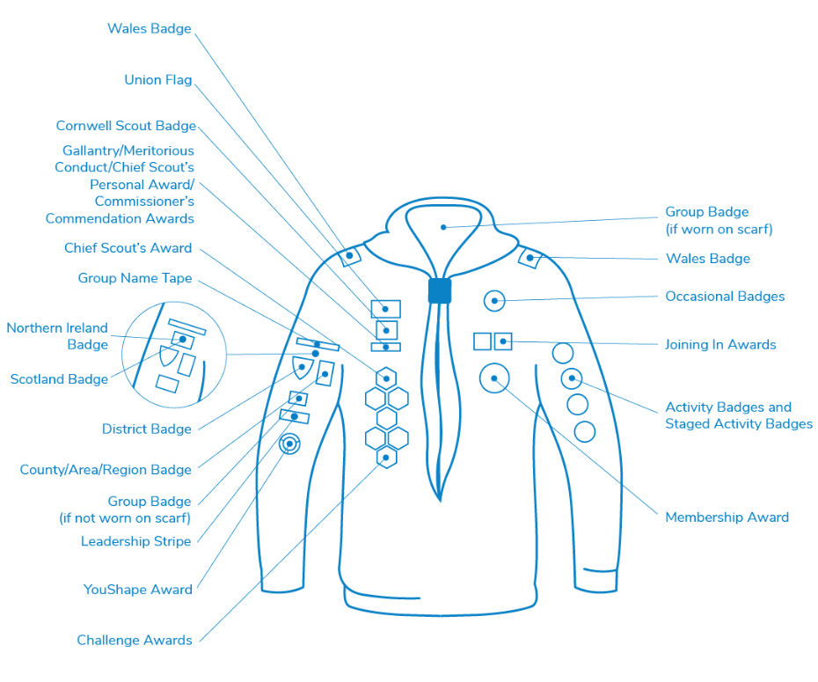
During his/her time in the colony, your child will be able to work towards a number of badges. The following diagram shows where these need to be positioned on the Beaver Uniform. You can find a larger version of this on our website under Group > Information > Uniform Information. Or on the Scout website here.
Beavers receive their scarf and several badges at their investiture (see paragraph 2.6). The main one is the Membership Award worn on the front. We have a green Group Name tape with yellow writing – 1st Claygate. Our County & District badges are combined into a single badge and we do not have a Group Badge.
The Challenge Award Badges form the centre of the balanced programme and are placed on the right hand side at the front.
Activity Badges and the Staged Activity Badges such as Air Activities, Emergency Aid, Animal Friend, Gardener and Space, to name but a few, complement the Challenge awards and are sewn down the left sleeve. The Staged badges can be transferred to the Cub uniform when you move on.
The Chief Scout’s Bronze Award is the highest available in the Beaver Scout section. Your Beaver must complete all six challenges plus 4 Activity Badges or staged Activity Badges to achieve this award. It is usually obtained as the Beaver moves up to Cubs and so can be sewn onto the cub uniform.
On the anniversary of joining the Group, your child will be presented with his/her Joining–in Award.
Occasional Badges are presented to commemorate special events and are usually only worn for a short period.
Further information on badges and awards is available on the website https://www.scouts.org.uk/beavers/awards/.

The Beaver Scout Promise
I promise to do my best and to be kind and helpful and to love God.
Alternative Promise
Scouting is available to people of all faiths as well as people who are humanist, atheist or have no affirmed faith and must therefore take account of the different religious obligations or non-religious beliefs of its Members.
To meet these circumstances, there are different variations of the Beaver Scout Promise that can be made, allowing for the individuals obligations while upholding the essential spirit of the Promise. These can be found here. Please speak to Hugh Gostling the Group Scout Leader or your child’s Leader if you would like your child to use a different promise.

The Beaver Scout Motto
Be Prepared.

The Investiture
This event usually takes place after your child has attended meetings for at least 4 weeks. The GSL or one of his deputies will be present at the normal weekly meeting and will ask your child to repeat the words of the promise after him. Your new Beaver Scout will then be presented with his/her Group Scarf, woggle and Group T-shirt which he/she will wear throughout his/her time in the Group, a certificate, and badges for his/her uniform. This is an important occasion and parents are invited to attend.

Moving Up to Cubs
Your child will be eligible to move on to Cubs when he/she is 8 years old and will be part of a group of Beavers who move up at the end of each term. By this time you should have had the chance to see what our cub packs get up to through taking part in events and reading our regular Newsletter. We hope you will have seen what’s in store through your attendance at our Scouts Own & Moving-Up Ceremonies each term.

Points of Interest
There is no longer a Beaver Scout Annual but there are various publications available from Scoutshops which make good stocking fillers!
Members of 1st Claygate Scout Group are proud to be able to wear a khaki coloured scarf to show that we were one of the first groups to join the Scouting Movement. The other groups have more colourful scarves but it is worth remembering why we are different.
Members of the Scout Association always shake hands with their left hand. This is a sign of trust which originates from Baden Powell’s meeting with Zulu warriors who laid down their shield (held in their left hand) to greet him.

About Group and District Activities
In addition to the weekly programme which you will receive from your colony Beaver Scout Leader at the beginning of each term, there will be activities organised at Group and District level. This chapter gives a general description of these which you will hear about through your colony. There may be changes to the format and venue of these activities so please treat this information as guidance only. A full calendar of events is available on our website – www.claygatescouts.org. You can sign up there to receive updates to the calendar and to see new photos of events. Please also note that you can usually sign up to help at events by completing a shared spreadsheet on our website. This saves the organisers or parent coordinator worrying about getting enough help.

Beaver District Party
This is organised by The Esher District Beaver Leader and usually takes place in February. There are around 250 Beavers from 11 groups in Esher District: 1st Claygate, 1st Cobham, The Dittons, 1st Hinchley Wood, 1st Molesey, 2nd Molesey, 3rd Molesey, 1st Oxshott, 4th Thames Ditton (Ajax Sea Scouts), 1st Weston Green & 3rd Esher.
It is usually held in Hinchley Wood Secondary School making use of the main hall and several classrooms. There is an opening ceremony where all Beaver Groups are introduced and a break for a packed tea half way through. Usually a theatre company performs a fairy tale or fable with a number of bases for groups of 20-25. A great time to meet and catch up with friends from other areas.

Cross Country Run
This event takes place in February and is organised by the District. It usually takes place on Oxshott Common. Beavers need to be accompanied on the run by a parent or other adult. Each young person participating receives a medal and points for their group.

Group Activity Weekend
Each year during May Explorers, Scouts, Cubs and Beavers have a weekend camp at either Polyapes (in Oxshott) or Walton Firs (in Cobham). Beavers may be invited to a sleepover for one night only in a hut where they will probably sleep in small pop-up tents with mats on the floor! Scout Association rules state that Beavers are only allowed to sleepover for a maximum of 24 hours. Our aim is that around two thirds of Beavers come for the sleepover and the rest are invited for the afternoon and evening. The Beavers attend the camp fire and the Scout’s Own and Going-up ceremony with the rest of the Group. The sleepover takes on a fun theme and is a good introduction to Scouting outdoors. One of the Beaver Leaders will be assigned the role of Leader in Charge supported by the team of leaders, assistant leaders and section assistants.

Beaver Fun Day
This takes place in July and is organised by the District with a similar format to the Beaver District Party with one major difference – it is held outside! It usually takes place at Esher District’s campsite at Polyapes, Blundel Lane, Oxshott in the main field. There are a series of bases which groups follow during the afternoon and it is a great deal of fun, especially if the weather is good! You will be encouraged to share lifts as the car park there is too small to accommodate 150+ cars!

Scouts Own & Going-up Ceremony
These take place on a Sunday morning soon after the beginning of each term (Feb, May & Oct). After a short service which is planned by the Group, the Beaver Leaders say goodbye to Beavers who are old enough to join one of the Cub Packs and they carry out some sort of activity such as climbing along a set of logs to their Akela (Cub Scout Leader). There are also tasks for Cubs joining Scouts and Scouts moving on to Explorers. This is a good opportunity to remind ourselves of the spiritual element of Scouting and to meet other members of the Group. There are sometimes special presentations to be made where for example money has been raised for charity and/or leaders have completed training or reached milestones in their service to scouting.

Group Beer Festival
In early September at the end of school holidays, we hold a weekend Beer festival. It is extremely popular in the community and is an enjoyable and profitable event for the Group.

Group AGM & Annual Awards
As a charity we need to hold an Annual General Meeting to present our accounts to the membership. This usually takes place in June or July and in addition to the short formal business there is a barbeque and awards to leaders and members. The annual awards were introduced in 2000 to reward individuals who have stood out in some way as representatives of scouting. Recipients of awards are chosen by the leaders of each section.

Claygate Flower Show
We always have a pitch at the Village Flower Show in July and any help with this event will be appreciated. The Scout Group is an important part of the community and this is a good forum for showing them what we are about! The Beaver Colonies try to enter the Group Category each year.

St Georges Day
This takes place towards the end of April and is usually held jointly with Hinchley Wood, Cobham and Oxshott so can be at either one of their village churches as well as our own. We take this as an opportunity for all members of the Scout Association to renew their promise so it is really important for all Beavers to attend. We do all we can to make the occasion interesting for younger members whilst recognising that it is for all ages.
The event usually begins with a march through the streets led by our band. Each colony has a flag which will be carried by a representative with two escorts. All members should be well turned out and apologies for non-attendance should be directed to our GSL.

Group Fireworks
Families are welcome to join us for a firework display around November 5th. Great fun in a safe environment.

Remembrance Day Parade
This is similar to St Georges Day but takes place in November and only involves 1st Claygate. We join members of the British Legion and the Guide Movement for a parade from the car park next to Champions in Hare Lane to Holy Trinity Church. Once again apologies for non-attendance must be sent to our GSL and smart uniform is essential.

Carols around the Camp Fire
This is organised by the Group on an evening near to Christmas and was first held in 2016. It involves an outdoor element singing carols around our campfire accompanied by the Band, and an indoor element which is a chance to share mulled wine and mince pies with Scouting friends. Everyone is welcome.

Subscriptions
Membership subscriptions are levied three times a year in April, September and January. They are calculated on an annual basis and reviewed annually by the Trustee Board. You will receive an email from our Treasurer requesting payment in the first weeks of term and will be asked to post monies to him or use the on-line system which is accessible from our website at http://www.claygatescouts.org/ .
The normal subscription for Beavers is £153 per annum (£51 per term). You will be advised of the rate when you join.

Subscriptions – by Gift Aid
We aim to collect Gift Aid on all subscriptions. As a recognised and registered charity, The Scout Group reclaims the tax as it has already been paid through the donor’s taxed income. This means that for every £1 of subscriptions you pay, the Group is able to claim an additional 25p.
This is obviously a very advantageous way for the Group to increase its annual income and is put to good use in the equipment and activities that the Group provides.
You will be prompted to donate in this way when paying your subscription - please do so if you can.

Group Behaviour Policy and Code
This policy was first introduced in 2011 and is ‘signed up to’ by parents and members over 8 years of age when joining or moving section. Latest versions of all policies are available on the website.
Verbal Warnings
If the behaviour of a Beaver/Cub/Scout/Explorer is considered to have fallen well below the ‘Group Code of Acceptable Behaviour’, that Beaver/Cub/Scout/Explorer, or group of Beavers/Cubs/ Scouts/ Explorers, will be given a verbal warning by a Leader. The offender(s) will be told to stop whatever they are doing and warned what will happen if they don’t comply.
Examples of unacceptable behaviour could be: -
- continual talking, or verbal disruption when a ‘Leader’ has asked for quiet;
- continuing with unacceptable or disruptive behaviour after being directly told to stop;
- persistent refusal to follow instructions, or the rules of a game.
Initial Formal Warnings (aka Yellow Card)
If a verbal warning is ignored, the Beaver/Cub/Scout/Explorer may be required to take a time out away from the other members of the sections. The form of this will vary from section to section. The Section Leader will record the name and details of the incident in the register. The parent(s) of the section member may also be contacted.
More serious bad behaviour could result in the immediate issue of an initial formal warning. Examples of this type of behaviour include:
- threatening language or behaviour – (not involving use of physical violence);
- careless disregard of property leading to its damage;
- challenging the authority of a Leader, Instructor or Helper.
Second level warnings (aka Red Card)
If the Beaver/Cub/Scout/Explorer commits a second Yellow Card offence on the same night they will receive a second level warning. Again, name and details of issue will be recorded and the Beaver/Cub/Scout/Explorer will not be allowed to take any further part in that evening’s Colony/Pack/Troop/Unit meeting.
Parent(s) will be advised of the issue of a second level warning, as soon as it is practical to do so. Depending on the situation the Section Leader may send for the parent/guardian to collect their child early. Sending a Scout home, (if he makes his own way to Troop meetings) could also be an option, but only after the parent/guardian had been contacted and advised.
Certain behaviour could result in the immediate issue of a second level warning. Examples of these include:
- bullying or physical unprovoked attack on another Group Member;
- blatant vandalism to property or equipment;
- deliberate defiance of clearly given instructions - particularly where safety is threatened.
Please note that some sections will operate this system using Yellow and Red cards:
Suspension - If a Beaver/Cub/Scout/Explorer receives a Red Card, he or she will automatically be suspended from the next two meetings and will not be allowed to attend camps or outings held during that month, or the next. In some cases the Section Leader may also request a letter of apology.
Continual Offending- If a Beaver/Cub/Scout/Explorer receives four Yellow Cards in any six-month period he or she will be suspended.
Appeal – If a Beaver/Cub/Scout/Explorer feels that they have been unfairly issued with either a Red or Yellow card, he or she can appeal to the Group Scout Leader to review the incident and punishment. Any appeal must be made within seven days of the issue of the card.
Exclusion- If a Beaver/Cub/Scout/Explorer receives three Red Cards (either as a Cub or Scout), then on issue of the third Red Card, exclusion proceedings will be initiated. This is a very serious matter involving the Section Leader, Group Scout Leader and District Commissioner and would result in exclusion from all Groups in the District.

